Degree Modifier

🔹 What Is Degree Modifier?
# Source: AI Source: Provided by: [Data Path: Persons Table -> ID Column: 1, Name_En Column: Motasem Essam] -> From: [Chatgpt (GPT‑5 Mini)] on [8/7/2025]
A degree modifier is a word (usually an adverb) that modifies adjectives, adverbs, or verbs by expressing intensity, extent, or degree.

🔸 Function:
# Source: AI Source: Provided by: [Data Path: Persons Table -> ID Column: 1, Name_En Column: Motasem Essam] -> From: [Chatgpt (GPT‑5 Mini)] on [8/7/2025]
It answers the question:
"To what extent?" or "How much?"

🔸 Common Degree Modifiers:
# Source: AI Source: Provided by: [Data Path: Persons Table -> ID Column: 1, Name_En Column: Motasem Essam] -> From: [Chatgpt (GPT‑5 Mini)] on [8/7/2025]
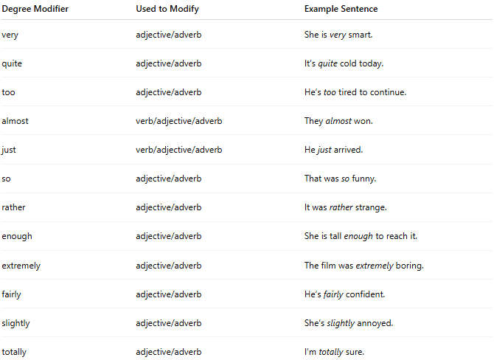
Degree Modifier | Used to Modify | Example Sentence
very | adjective/adverb | She is very smart.
quite | adjective/adverb | It’s quite cold today.
too | adjective/adverb | He’s too tired to continue.
almost | verb/adjective/adverb | They almost won.
just | verb/adjective/adverb | He just arrived.
so | adjective/adverb | That was so funny.
rather | adjective/adverb | It was rather strange.
enough | adjective/adverb | She is tall enough to reach it.
extremely | adjective/adverb | The film was extremely boring.
fairly | adjective/adverb | He’s fairly confident.
slightly | adjective/adverb | She’s slightly annoyed.
totally | adjective/adverb | I’m totally sure.

🔸 Placement:
# Source: AI Source: Provided by: [Data Path: Persons Table -> ID Column: 1, Name_En Column: Motasem Essam] -> From: [Chatgpt (GPT‑5 Mini)] on [8/7/2025]
- Usually placed before the word it modifies (except for enough, which comes after the adjective/adverb).

🔸 Examples in Sentences:
# Source: AI Source: Provided by: [Data Path: Persons Table -> ID Column: 1, Name_En Column: Motasem Essam] -> From: [Chatgpt (GPT‑5 Mini)] on [8/7/2025]
- The task was too difficult. (modifies "difficult")
- He ran very quickly. (modifies "quickly")
- They are almost ready. (modifies "ready")
- She didn’t study enough. (modifies "study")
- It’s so good to see you! (modifies "good")

